

**High Impact Skills Development Program for Gilgit-Baltistan**

**Computer Vision Module Project**

**Name: zohaib Hassan**

**student of: Artificial Intelligence(AI)**

**Gmail:** [**zohaibhunzai121@gmail.com**](mailto:zohaibhunzai121@gmail.com)

**linkedin:** [**https://www.linkedin.com/in/zohaib-hassan-811310252/**](https://www.linkedin.com/in/zohaib-hassan-811310252/)

**Github:** [**https://github.com/zohaibhass**](https://github.com/zohaibhass)

**SUMMARY OF PROJECT**

Understanding and measuring high-level interpersonal qualities between people and face images is the main goal. The research suggests a deep network architecture that is capable of accurate face emotion identification. In contrast to conventional models that just learn from facial expression labels, their multitask network incorporates auxiliary characteristics like gender, age, and head position in addition to face expression labels for improved learning. To predict the link between people precisely and finely in order to foresee interpersonal ties, they use the expression recognition network as branches for a Siamese model. Numerous experiments demonstrate how effective their method is in capturing mutual context from faces.

* **Problem Overview:**

The era very goes to the visual analysis for many applications domain in various sectors like healthcare, system antennation, and many more. Our problem related to recognition, while the reconstruction of information after some processed and identifiable to be a challenging task. In this mini project, we are going through facial recognition using a family deep neural network and fine tuning to overcome this misleading identification.

* **Literature Review:**

A deep network architecture that accurately recognizes facial expressions was suggested by the researchers. Their multitask network additionally includes auxiliary parameters like gender, age, and head pose for increased learning, in contrast to standard models that simply learn from facial emotion labels [1]. In order to reduce the requirement for entire attribute labels in the training dataset, they present a unique attribute propagation approach. As a result, the network may take advantage of the linkages between various attribute sources despite the fact that their distributions vary [2]. The suggested method performs at the cutting edge on benchmarks for facial expression recognition. They employ the expression recognition network as branches for a Siamese model to accurately and finely forecast the association between persons in order to anticipate interpersonal relations. Numerous tests show how well their model works when mining mutual context.

* **Methods and material**

**To address the problem objective, we are adopting basic machine and deep learning general steps as follow:**

1. **dataset:**

We will use a dataset for facial expression recognition, which contains 91,793 faces that have been manually annotated with various expressions, for this computer vision challenge. The seven main expression categories—angry, disgust, fear, pleased, sad, surprised, or neutral—are each assigned to one of the face images.

2.  **Preprocessed :**

The images are preprocessed for some fundamental operations, such as rescaling, augmentation, and normalization, to reduce computation time and get the best learning.

3.  **Split method:**

The entire dataset was partitioned into train, validation, and test portions in this step. 70%, 15%, and 15% are the ratio.

4. **Model architecture:**

For multiple classification, a convolution neural network with three covnet layers and an activation response function is used.

5. **Model architecture:**

We have three epochs to employ the train model in order to apply the aforementioned architecture to the train ratio with the validation test for seek. Finally, test the training's effectiveness using the test ratio.

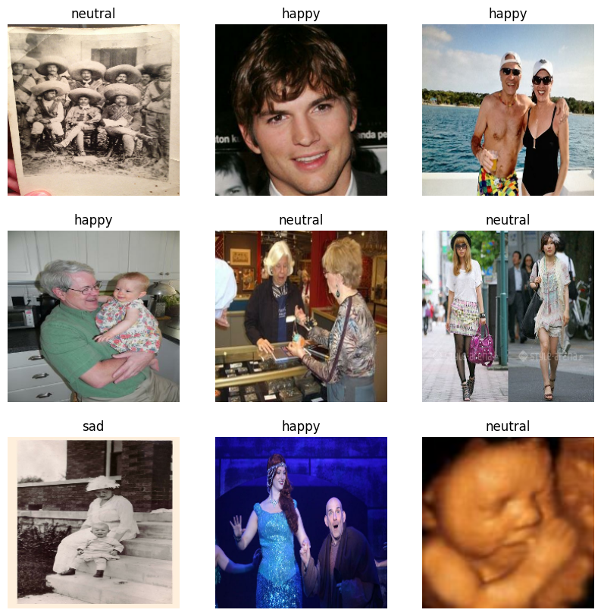

6.**Model performance:**

This is the final phase in the overall ML and DL process, and it provides information about the model's classification accuracy as a confusion matrix.

* **Results and Evaluations:**

I obtain fifty-five plus accuracy in the first three epochs as I share my GitHub repository. Due to my system's limited capacity, I was unable to run more than 5 epochs.

* **Future Recommendations:**

Our suggestions include employing a different architecture, such as Resnet, Vgg16,19, and so forth, the face classification task to fine-tune hypermeters, and finally running tests to analyze terms like correctness, overfitting, and underfitting.

* **Reference:**

Those authors include Karnati, Seal, Bhattacharjee, Yazidi, and Krejcar (2023). An extensive overview of deep learning methods for facial expression analysis to identify human emotions. Instrumentation and Measurement Transactions of the IEEE.

August 2006: Marlow, C., Naaman, M., Boyd, & Davis. To read: HT06, taxonomy paper, Flickr, and academic article. The seventeenth conference on hypertext and hypermedia proceedings, pp. 31–40.

**GITHUB LINK TO ABOVE PROJECT:**

<https://github.com/zohaibhass/computer-vision-expression-detection-/blob/main/CV_moduls_project.ipynb>